**Test Cases**

**for**

**FitBuds**

**Version 1.0 approved**

**Prepared by Team SAMMY**

**Nanyang Technological University**

**20th October 2022**

**Revision History**

|  |  |  |  |
| --- | --- | --- | --- |
| **Name** | **Date** | **Reason For Changes** | **Version** |
|  |  |  |  |
|  |  |  |  |

Test Cases

# Black Box

## Equivalence Class & Boundary Value Testing

|  |  |  |  |  |
| --- | --- | --- | --- | --- |
| Type | Requirement | Valid EC | Invalid EC(s) | BV (if applicable) |
| Range of values | Must contain a minimum of 8 characters | Valid password  X.length>=8 | Invalid password  x.length <=7 | X.length=7,8 |
| Range of values | Must contain at least one letter | Lettercounter(x)>=1 | Lettercounter(x)<=0 | Lettercounter(x)=0,1 |
| Range of values | Must contain at least one number | Numbercounter(x)>=1 | Numbercounter(x)<=0 | Numbercounter(x)=0,1 |
| Discrete value | Must not contain username | x.contains( username)==false | x.contains( username)==True | NIL |

## Test Results

Username=John

|  |  |  |
| --- | --- | --- |
| Test Input | Oracle | Log |
| Password | Expected Output | Actual Output |
| ilovesc2006 | No output message, app allows user to proceed |  |
| johnlovesc2006 | “Password contains username”, user is not allowed to proceed |  |
| ilovescse | “Password does not contain any numbers”, user is not allowed to proceed |  |
| 12345678 | “Password does not contain any character”, user is not allowed to proceed |  |

# White box

## Pushup counter

### Control flow graph:

*a clearer diagram is included in the directory

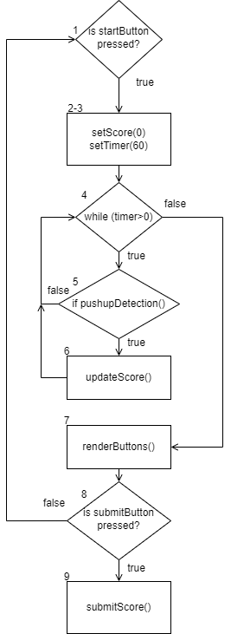

### Cyclomatic complexity:

10 edges – 8 nodes + 2= 4-> 4 basis paths to test

|  |  |
| --- | --- |
| Index | Basis Path |
| 1 (baseline) | 1,2-3,4,**5,6**,4,7,8,9 |
| 2 | 1,2-3,4,**5,4**,7,8,9 |
| 3 | 1,2,3,4,5,6,4,7,**8,1**,2-3,4,5,6,4,7,8,9 |
| 4 | 1,2,3,4,5,6,4,7,8,1,2-3,4,**5,4**,7,8,9 |

### Test Results

|  |  |  |
| --- | --- | --- |
| Test Input(s) | Expected Basis Paths | Real execution Path |
| Press start, do 1 pushup in 60s, submit score | 1,2-3,4,5,6,4,7,8,9 | 1,2-3,4,5,6,4,7,8,9 |
| Press start, do 0 pushup in 50s, submit score | 1,2-3,4,5,4,7,8,9 | 1,2-3,4,5,4,7,8,9 |
| Press start, do 1 pushup in 60s, press start, do 1 pushup in 60s, submit score | 1,2,3,4,5,6,4,7,8,1,2-3,4,5,6,4,7,8,9 | 1,2,3,4,5,6,4,7,8,1,2-3,4,5,6,4,7,8,9 |
| Press start, do 1 pushup in 60s, press start, do 0 pushup in 60s, submit score | 1,2,3,4,5,6,4,7,8,1,2-3,4,5,4,7,8,9 | 1,2,3,4,5,6,4,7,8,1,2-3,4,5,4,7,8,9 |

*a clearer diagram is included in the directory

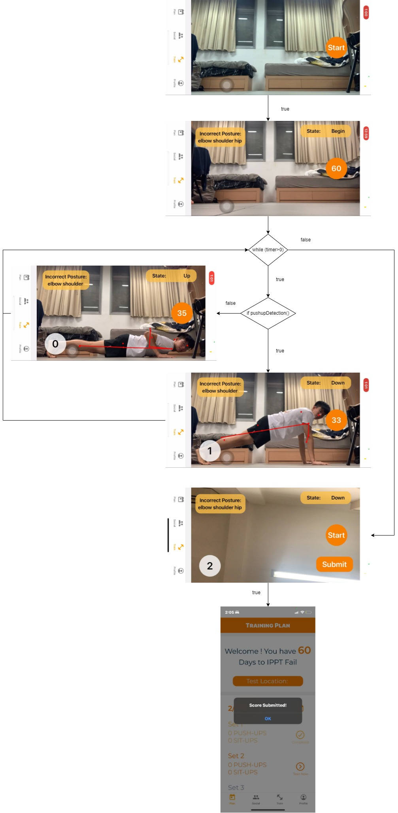

## Strava Authentication

### Control flow graph:

*a clearer diagram is included in the directory

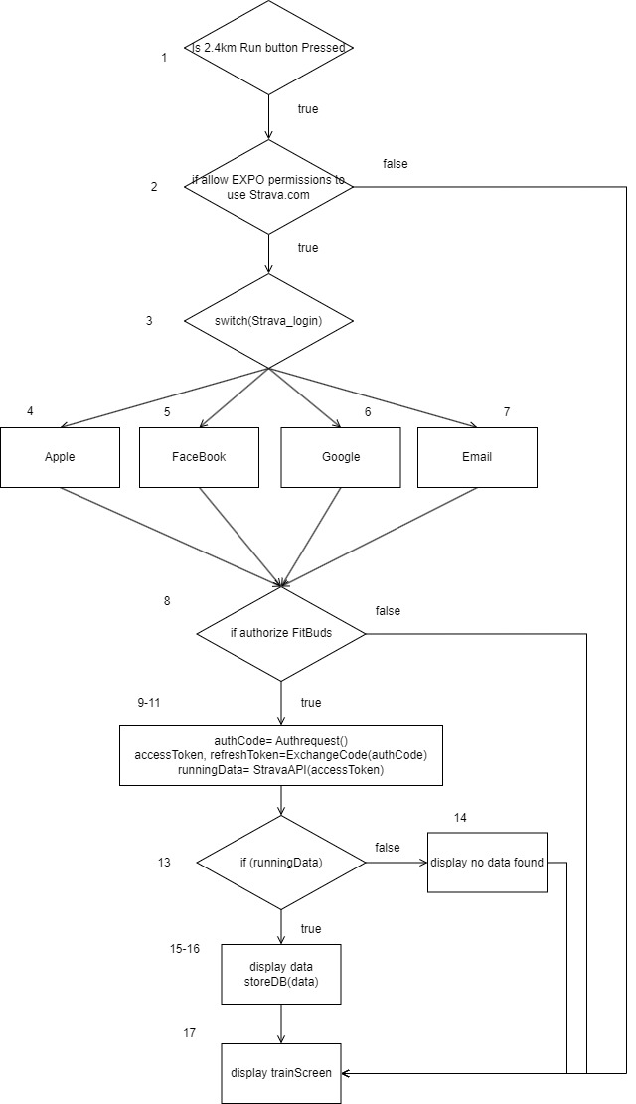

### Cyclomatic complexity:

CC= 18edges - 13nodes +2= 7-> 7 basis paths to test

|  |  |
| --- | --- |
| Index | Basis Path |
| 1 (baseline) | 1,2,**3,4,**8,9-11,13,15-16,17 |
| 2 | 1,2,**3,5**,8,9-11,13,15-16,17 |
| 3 | 1,2,**3,6**,8,9-11,13,15-16,17 |
| 4 | 1,2,**3,7**,8,9-11,13,15-16,17 |
| 5 | 1,**2,17** |
| 6 | 1,2,3,4,**8,17** |
| 7 | 1,2,3,4,6,8,9-11,**13,14**,17 |

### Test Results:

|  |  |  |
| --- | --- | --- |
| Test Input(s) | Expected Basis Paths | Real execution Path |
| Press 2.4km run button, allow EXPO permissions, sign in with Apple, authorize FitBuds, have running Data | 1,2,3,4,8,9-11,13,15-16,17 | 1,2,3,4,8,9-11,13,15-16,17 |
| Press 2.4km run button, allow EXPO permissions, sign in with Facebook, authorize FitBuds, have running Data | 1,2,3,5,8,9-11,13,15-16,17 | 1,2,3,5,8,9-11,13,15-16,17 |
| Press 2.4km run button, allow EXPO permissions, sign in with Google, authorize FitBuds, have running Data | 1,2,3,6,8,9-11,13,15-16,17 | 1,2,3,6,8,9-11,13,15-16,17 |
| Press 2.4km run button, allow EXPO permissions, sign in with Email, authorize FitBuds, have running Data | 1,2,3,7,8,9-11,13,15-16,17 | 1,2,3,7,8,9-11,13,15-16,17 |
| Press 2.4km run button, deny EXPO permissions | 1,2,17 | 1,2,17 |
| Press 2.4km run button, allow EXPO permissions, sign in with Apple l, unauthorize FitBuds | 1,2,3,4,8,17 | 1,2,3,4,6,17 |
| Press 2.4km run button, allow EXPO permissions, sign in with Apple, authorize FitBuds, no running Data | 1,2,3,4,6,8,9-11,13,14,17 | 1,2,3,4,6,8,9-11,13,14,17 |

*a clearer diagram is included in the directory

